



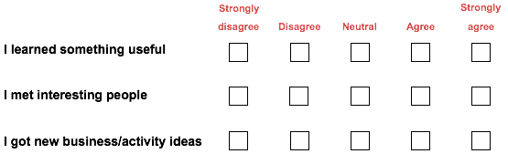

My favourite & least favourite parts of the event were…